LED Kennlinien

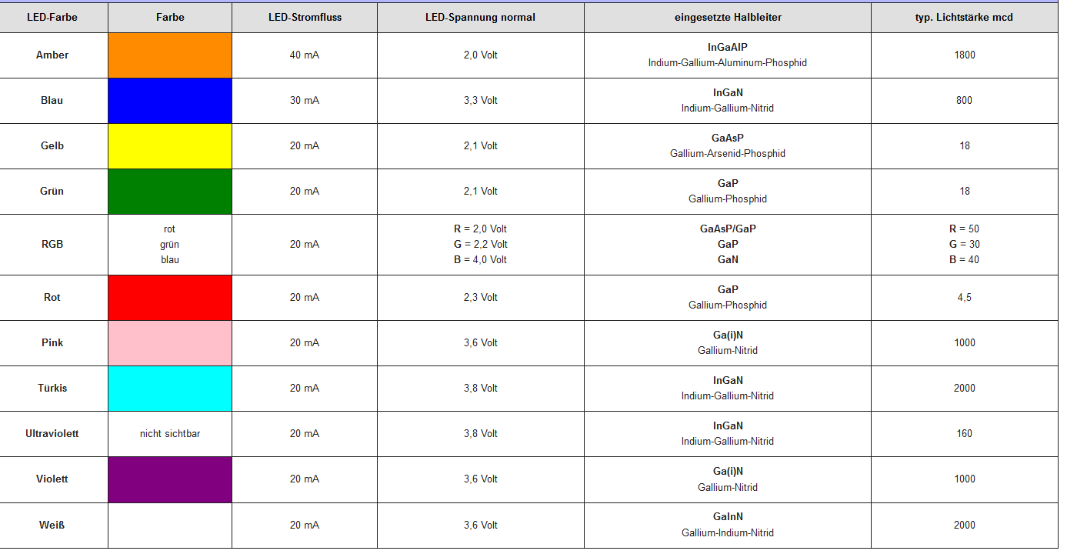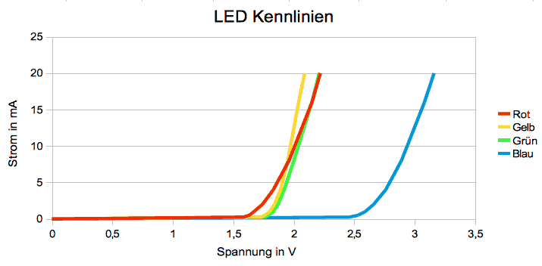

<https://www.reichelt.de/reicheltpedia/index.php/LED>

<iframe src="https://www.google.com/maps/embed?pb=!1m18!1m12!1m3!1d5283.328360571908!2d13.575649227766268!3d48.539667117030206!2m3!1f0!2f0!3f0!3m2!1i1024!2i768!4f13.1!3m3!1m2!1s0x4774600d1b0ed515%3A0x6e2f535bd47d45db!2sKonrad%20Dullinger!5e0!3m2!1sde!2sat!4v1579773197879!5m2!1sde!2sat" style="border:0;" allowfullscreen="" width="600" height="450" frameborder="0"></iframe>

Naxvkwsyre63

Naxvkwsyre63%